Journey Through The Bible

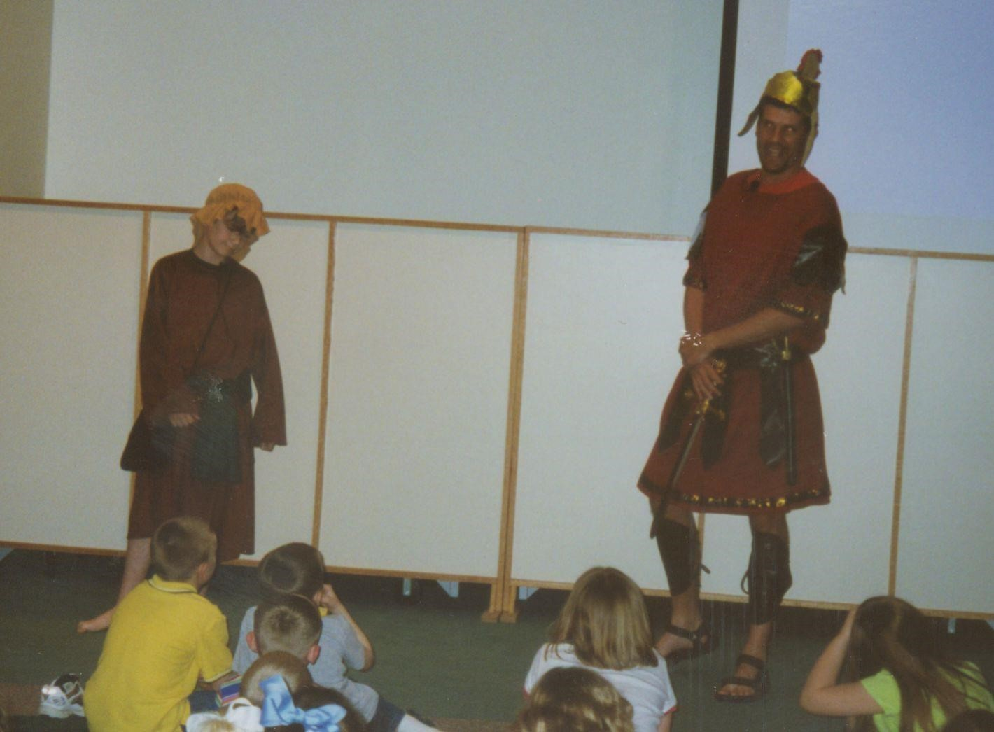

**DAVID AND GOLIATH**

1 Samuel 17:1-58

Hello, I'm David from Bethlehem in Judah. I'm one of Jesse's eight sons. I want to tell you about an exciting adventure. One day the Philistines, our enemy, and Saul, our king, had drawn their battle line. They were on one hill and we were one the other one with a valley between us.

My father Jesse said to me, "Take this roasted grain and these ten loaves of bread for your brothers and hurry to their camp. Take along these ten cheeses to the commander of their unit. See how your brothers are and be sure everything is all right with them. They are with Saul and all the men of Israel in the Valley of Elah, fighting against the Philistines, our enemies." Early the next morning I left the sheep with a shepherd, loaded up the food and left as my father Jesse had asked me to do. I reached the camp as the army was going out to its battle positions, shouting the war cry. Israel and the Philistines were lining up their men to face each other. I left the food that I had brought with the supply keeper and ran to the line where our army was lined up to see my brothers. As I was talking with them, Goliath, the giant, stepped out from his lines.

I am Goliath, the Philistines champion. I am over 9 feet tall. My helmet is bronze, I have on a coat of armor, I have bronze armor on my legs, and a bronze spear slung on my back. I also have a shield bearer. I yelled at the Israelites, "Why are you lining up for battle? Am I not a Philistine, and are you not the servant of Saul? Choose a man and have him come down to me. If he is able to kill me, we will become your subjects; but if I kill him, you will become our slaves and do everything that we tell you to do. I dare you to send a man to fight me." For forty days every morning and every evening and challenged the Israelites.

DAVID: I don't need to tell you how scared we all were.

GOLIATH: I dare you to send a man to fight me!

DAVID: I heard someone say, "Do you see how this giant keeps coming out? He comes out to challenge us. I asked the men standing near me, Who is this Philistine that he should challenge the armies of the living God? Then they told me what they had been saying, “This is what will be done for the man who kills this giant and removes this shame. The king will make the man rich who kills him. He will also give him his daughter to marry and his father's family will not have to pay any taxes.”

My brother Eliab saw me talking to the men. He seemed angry. He said, "Why have you come down here? Who did you leave with the sheep." He then said something that shocked me, "I know how you think you only came down to watch the battle." I said "Now what have I done?" Can't I even talk? I then began talking to someone else that was nearby. What I said was reported to Saul, and he sent for me. I told Saul to "Let no one lose heart of account of this giant; I will go and fight him."

King Saul told me that I was just a boy and that I couldn't fight Goliath. He said that Goliath had been fighting since he was a boy. But I told King Saul that while keeping my father's sheep, a lion and later a bear came and carried off a sheep from the flock. I went after it, hit it and saved the sheep from its mouth. Then it turned on me, I grabbed it by its hair, hit it and killed it. I have killed both the lion and the bear. Goliath will be like one of them, because he has mocked the armies of the living God. My Lord who delivered me from the paw of the lion and the paw of the bear will deliver me from the hand of Goliath. Then Saul said to me, "Go, and the Lord be with you."

DAVID: Then Saul dressed me in his own clothes; he put a coat of armor on me and a bronze helmet on my head. I

fastened on his sword over the clothes and tried walking around, since I was not used to them. "I cannot go in these," I said to Saul, "because I am not used to them." I took them off. I chose five smooth stones from the stream, put them in my shepherd's bag and with my slingshot in my hand, I approached Goliath.

GOLIATH: I told my shield bearer to stay in front of me and we moved toward David. I noticed that he was just a boy, healthy and handsome looking. I thought to myself that I hated him. I said "Am I a dog, that you come at me with sticks?" Then I shouted "Come here and I'll give your body to the birds of the air and the beasts of the field."

DAVID: I told Goliath, “You come against me with sword and spear, but I come against you the name of the Lord Almighty, the God of the armies of Israel, whom you have mocked. Today the Lord will hand you over to me, and I'll strike you down and cut off your hear. Today I will give the bodies of your army to the birds of the air and the beasts of the earth, and the whole world will know there is a God in Israel. Everyone gathered here will know that it is not by sword or spear that the Lord saves. The battle is the Lord's and he will give all of you into our hands."

GOLIATH: I ran toward David and was ready to attack him. I saw David run quickly toward the battle line to meet me. He reached into his bag and took out a stone; he slung it and struck me on the forehead. The stone sank into my forehead and I fell facedown on the ground.

DAVID: I killed the Philistine, Goliath, with a sling and a stone. I ran and stood over him. I took Goliaths sword from his holder and cut off his head. When Goliath's army was that their hero was dead, they turned and ran. Our army ran forward shouting and running after the Philistines. They then tore up their camp. After I had killed him I was taken before Saul, while I was holding Goliath's head. He asked me whose son I was and I told him that I was the son of his servant Jesse of Bethlehem. I love God and he has taken care of me today!

**Memory Verse:**

☼ Ask, and it will be given to you; seek, and you will find.

**What did you learn from this lesson?**

☺ David put his faith and trust in God. **Do you know? Answer on back page ?** **Did David kill Goliath alone?**

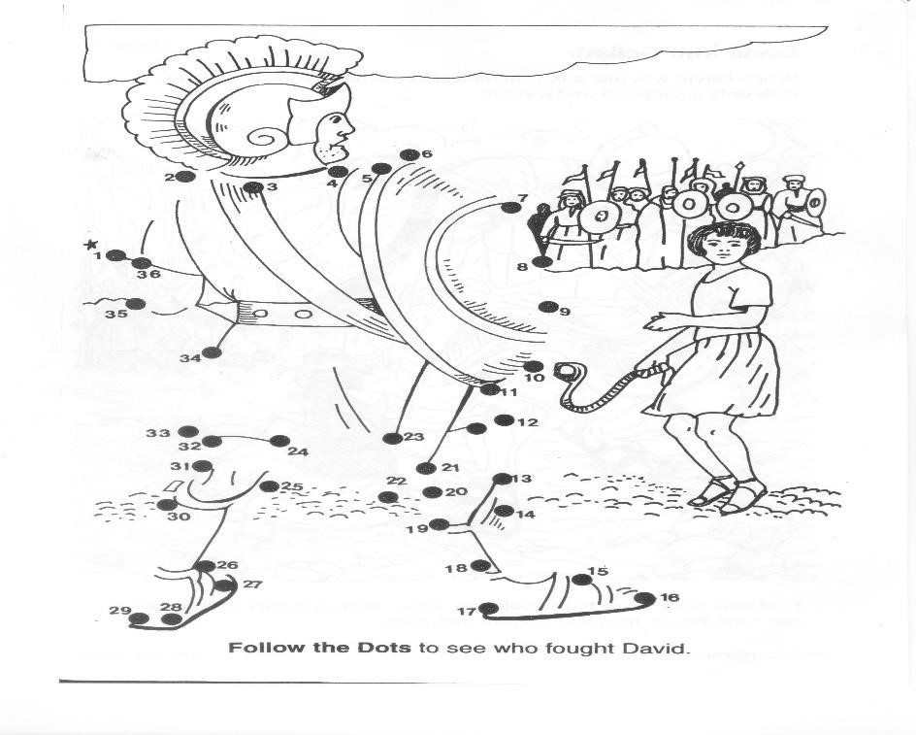

**? Answer to do you know. ● No, God was with David.**